# **Python Coding Assessment #1**

**Ques.1**

MAKE A PROGRAM TO MERGE TWO LIST INTO A SINGLE DICTIONARIES

● Take inputs from the user

● Any one list must contain unique elements

● both the list should be of the same size

● both the list should be a combination of numbers and names

● Name of dictionary you can take it accordingly

**Ques 2.**

Write a program that converts Paragraph to List

● Take input from the user in string form(a sentence or para)

● All the words in the string having more than 4 letters should be stored in a list

*Sample Input* : A paragraph is defined as “a group of sentences or a single sentence that forms a unit”. Length and appearance do not determine whether a section in a paper is a paragraph.

*Sample Outpu*t : [ ‘paragraph’ , ‘defined’, ‘group’ , ‘sentences’ , ‘forms’ , ‘Length’,‘appearance’ , ‘determine’ , ‘whether’ , ‘section’ , ‘paper’ , ‘paragraph’ ]

**Ques 3.**

Raining like cats and dogs

● Take user input in the form of a string.

● Return True if in the string "cat" and "dog" appear the same number of times in the given string

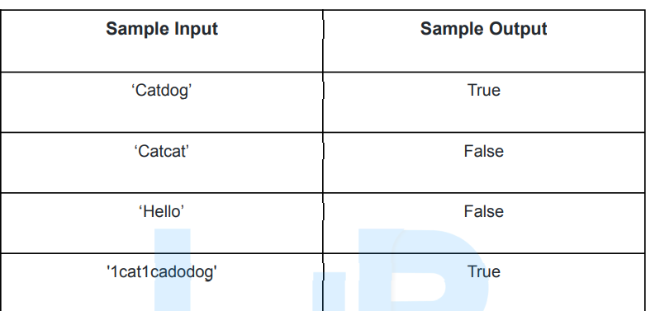

**Ques 4.**

Calendar

● Take input from the user in form of three integers

● The three integers represent a year, month and day

● Print the season of that month and day

● Now check whether the given year is a leap year or not

● If the year is a leap year then print the number of days in that year else print the

next leap year

**Ques 5.**

Trekking with friends

● Three friends Suman, Amit and Ravi have gone for trekking and there they

decided to plan a racing among themselves

● Amit beats Suman by A meters, Ravi by B meters and Suman beats Ravi

by C meters

● Find the total length of trek they all have traveled

*Sample Input*: A= 10 m, B= 20 m, C= 12m

*Sample Output:* Total length of the Track= 60 m

**Ques 6.**

Filter

● Create a function even_filter with one parameter. This function will return a

list which will contain only odd values.

● Create a function odd_filter with one parameter. This function will return a

list which will contain only even values.

● Call the function even_filter and pass a list of numbers as an argument.

● Call the function odd_filter and pass a dictionary as an argument.

● NOTE: The list and dictionary must be user define

**Ques 7.**

Greatest Common Divisor

● Take a user input in a list consisting of 2 or more than 2 numeric values.

● Find the GCD of the numbers of the list using a user defined function.

**Ques 8.**

Write a program to print twin primes less than 1000. If two consecutive odd numbers are both prime then they are known as twin primes.

Define two functions checkPrime(): which checks whether the number is prime or not. If yes then return it.

The second function twinPrime(): Generates the list of twin primes and returns them.

**Ques 9.**

Write a program using functions to implement these formulae of permutations and combinations.

Number of permutations of n objects taken r at a time: p(n, r) = n! / (n-r)!.

Number of combinations of n objects taken r at a time is: c(n, r) = n! / (r!*(n-r)!) = p(n,r)/r!

**Ques 10**.

If all digits of a number n are multiplied by each other repeating with the product, the one digit number obtained at last is called the multiplicative digital root of n. The number of times digits need to be multiplied to reach one digit is called the multiplicative persistence of n.

Example: 86 -> 48 -> 32 -> 6 (MDR 6, MPersistence 3)

341 -> 12->2 (MDR 2, MPersistence 2)

Define three functions : prodDigits(): that finds the product of digits of a number, function MDR() and MPersistence() that input a number and return its multiplicative digital root and multiplicative persistence respectively.

**Ques 11.**

Given a list of integer numbers and an integer target, return indices of the two numbers such that they add up to target.

You may assume that each input would have exactly one solution, and you may not use the same element twice. You can return the answer in any order.

*Input: nums = [2,7,11,15], target = 9*

*Output: [0,1]*

*Explanation: Because nums[0] + nums[1] == 9, we return [0, 1].*

**Ques 12**.

‘Nand’ is an operator that is false only when both of its operands

are true. Python doesn’t have a nand operator, so how can we

write an expression that is equivalent to A nand B?

**Ques 13.**

This question is based on a function for stepping through a representation of a pack of cards. The exact nature of the cards isn’t important.

We use a list to represent pack and in our example we use numbers

between 1 and 5 as cards. They could equally be numbers and suits as

tuples, strings of character names, etc.

Here’s the function:

# A hand of cards

cards = [ 1 , 5 , 3 , 4 , 2 , 3 , 2 ]

def nextCard ( cards ) :

next = cards[0]

newHand = cards[1:] + [ cards[0] ]

return next , newHand

• What is the type of values returned by this function?

• Describe in words what the function does.

• It would be a simple matter for this function to alter the input list

so that the first element becomes the last. This would simplify

the return value, which is currently two items. Why might this

be considered a poorer solution than the function as it is now?

• Write a loop that calls this function repeatedly, printing out the

card from the top of the deck each time.

• Using the given function and your answer to the previous question as a starting point, write a program that checks a deck of

cards for consecutive identical pairs (a 2 followed by a 2, for

example). If a pair is found, a message should be displayed.

• What happens if the input list is empty? Correct the function so

that it returns ( None , [ ] ) when an empty list is used as input.